May 2017

Dear Teachers, Parents, and Students:

This year’s summer reading theme is “Build a Better World” and the Michigan eLibrary (MeL) is here to help! Students of all ages can go to MeL.org to find eBooks and articles to read, conduct research, prepare for high stakes tests like the SAT®, or maintain/improve basic skills.

MeL provides all Michigan residents free access to quality, vetted subscription databases that can be used all year. Resources are available 24/7 and are mobile compatible. Our awesome content providers have created a few short videos for you that highlight their resources for summer use; you can check them out on the MeL YouTube channel playlist “Summer Slide Videos from our Partners” : (https://goo.gl/fDC4Be). While you are there, be sure to subscribe to the MeL Channel, so you can keep up to date with the latest tutorials and videos from MeL!

Within MeL, you can find quality resources and weblinks organized into convenient portals. For children from birth to 5th grade, MeL Kids (kids.mel.org) has four centers that will help support and build basic skills such as reading and math. For the older students in grades 6 through 12, MeL Teens (teens.mel.org) offers a wealth of resources to not only maintain and build basic skills, but also improve research skills and help students prepare for life after high school with college or career information. You can easily access the subscription databases in the Homework Help sections of these portals, or simply go to the A to Z database list (databases.mel.org).

This summer, stop by your local public library for programming and learning opportunities. But don’t forget to also use some of the Michigan eLibrary’s popular K-12 databases featured in the attached table. Dive into MeL to help slow down the summer slide and “Build a Better World”!

Sincerely,
The Michigan eLibrary Team
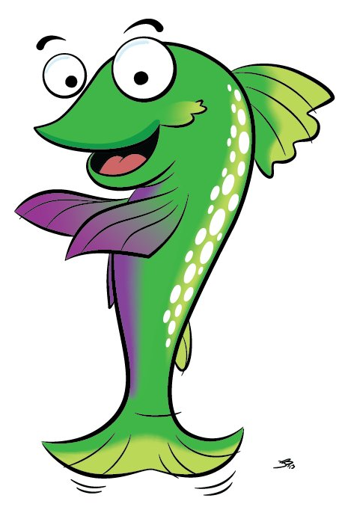

Database Name | Grade Level | Features
Britannica School  Britannica Learning Zone  Britannica Elementary  Britannica Middle  Britannica High | PreK - 12 | - Change reading levels with a click  - Read aloud feature  - STEM resources  - Articles, Videos, Images, Maps, Primary Sources and more!
Early World of Learning | PreK - 2 | - Look and Read  - Includes stories, nursery rhymes, songs, games, and videos.
eBooks  eBooks K-8 | Pre-K - adult | - eBooks can be downloaded or viewed via PDF version  - K-8 is a subset of the main collection and contains nearly 11,000 titles chosen to support a quality learning experience for K-8 students across all subject areas taught in elementary and middle schools
Kids InfoBits | PreK - 5 | - 3,000 images  - 1,700+ kid-friendly charts and graphs  - Nearly 600 high-quality educational videos  - Contains content in popular subject categories including Animals, Arts, Geography, Health, Literature, People, Social Studies, Technology, and more.
LearningExpress Library | 4 - adult | - Practice tests, Tutorials, and eBooks  - College Prep Center: SAT, ACT, PSAT practice  - School center: Math & Reading skills improvement tutorials starting in the 4th grade
NoveList K8+ | PreK - 12 | - Find just the right book  - Reading lists  - Book reviews
Research in Context | 6 - 8+ | - Designed to support the developing information and digital literacy skills of the average middle school student  - Nearly 300 topic pages  - 750+ Science videos
Scholastic BookFLIX | PreK - 3 | - Interactive eBooks  - Pairs fiction and nonfiction texts  - Fiction tests are Weston Woods Videos  - Interactive games to help improve sequencing, vocabulary, and fact versus fiction
World Book for Kids | PreK - 5 | - Activities and Science Projects centers  - Learn about people, places, animals, sports, and more  - Includes videos, images, maps, games  - Hear text read aloud

